Kazon Stormhammer

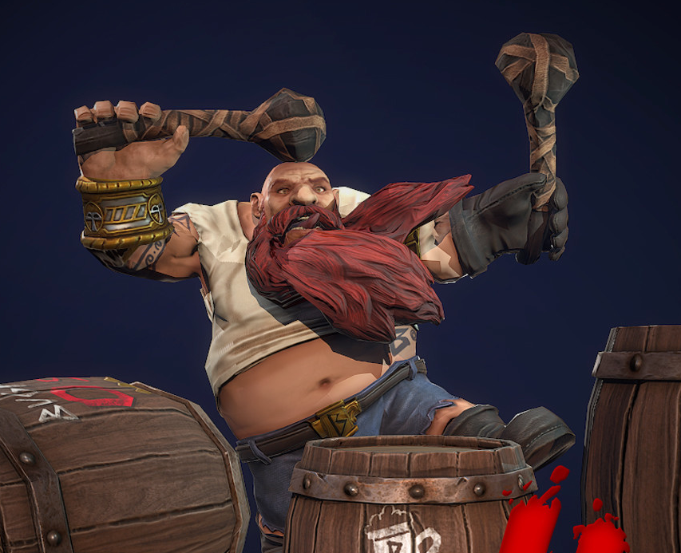

The tradition of dwarven bards is as old as their forges. It began with singing songs in rhythm with the beat of the hammers. Those with the best voices became revered and often took up the role of leaders and handled any bargaining needed for materials or sales of finished goods. Some took it as their task to memorize important ratios and timings for smelting or alloys. Eventually, after many decades of passed down tradition, these knowledge keepers also became knowledge seekers. A few left the forge to see if there was any knowledge of the earth to be learned outside their mountains. Rarely did they find anything useful, but when they did they passed that information down as well.

The Stormhammer clan has been a family of Coggers for ten generations and Kazon, as eldest son, was brought up to take of the role his father held. He did so, and loved the work. He loved the forge and his fellows. He soaked himself in the ancient knowledge of his people and absorbed it greedily. When it came time for him to leave the mountain and search the world for any bit of information that might increase the knowledge of his people, he was unwilling. Of course once he left he found it hard to come back.

Cogging — The reducing operation in which an ingot is worked into a billet by the use of a forging hammer or a forging press.

Kazon is 203 years old and has red hair and beard. He’s a bit tubby these days, having become a bit lazy in travels.

Family
- Father: Kalden Stormhammer. Now retired, old and nearly senile, Kalden was only an average Cogger, but a well-loved one. Kalden had a perfect sense of rhythm and was very good at the forge, but his ability to retain information was lacking. Kazon got to know Coggers from other clans and they taught him what his father had forgotten.
- Mother: Aslynne Stonemall was born to a clan of miners. Not a particularly well-respected clan at that. But she was popular for her exceptional skill as a chef and her friendly disposition. Kalden tried to get her attention for months, but he was only one of dozens and did not stand out among them. It was his brother, Deklin, that put her eyes on Kazon. He managed to get Aslynne to the forge when Kalden was working. His resonant voice, strength, and undeniable skill at the forge peaked her interest enough to get them started. While their relationship was never perfect, there was something deeper to their bond than any of their fights could overcome. Aslynne is still healthy and spends her days tending to Kalden and running the family businesses.
- Sister: Jolute is the eldest child and favorite of the family. She has the best qualities of both of her parents. Clever and beautiful, she runs the family mining operation along with her husband Throstrin Flintthane, who runs their small brewing business. They have one child, Scavrig, who has chosen to follow after his uncle Kazon, and is now the clan’s primary Cogger.

Education
Kazon was trained in the traditional way for Coggers. Time in the forge listening to the stories of the smiths. Time in private learning sessions with old Coggers learning the history of his people. Time studying the details and recipies of the forge. Evenings listening to his father over meals and drinks. There was little formal education and a whole lot of soaking in the actual work and lives of dwarves.

Life
He makes his money these days performing and teaching. He lives wherever he can with whatever money remains after drinking and eating is done. Sometimes he works for patrons for a few months, living in fancy mansions and entertaining (humans usually). Sometimes he works in forges to keep up his rhythm with the hammer and to sate his love of smithing.

Hobbies
He lives his hobbies for the most part. He collects old tomes from every culture. He learns what he can from them, then either sells them or donates them to a library that he trusts. This has become one of the things that will drive him from place to place, rumors of old, dusty books. Also, he has an odd fascination with birds. To him they represent everything that interests him about the world outside the mountains. Currently he has a pet parrot that he calls Kamaria after a girl he liked when he was very young.

Faith
Kazon gives obedience to Moradin, as almost every dwarf does, but he follows the tenets of Dugmaren Brightmantle. His worship is very lax and only really hits him when he is in the throws of his music.

Pets
Various brightly colored birds over the decades. Currently a parrot named Kamaria.

Relationships
Kazon hasn’t had a close relationship is a long time. He knows and likes a lot of people, but hasn’t formed any real bonds with anyone since leaving home.

Personality
Outwardly Kazon is a jovial dwarf, just the type that makes friends easily. Inside he is driven by a need to be of value to his people when he returns. This, however, is defeated by his increasing love of the world around him. He is constantly driven to the next city, camp, or village to find out what might be there.

Motivation
See above

Former Class: Bard

Former Alignment: Neutral Good

Reason for Saving the World
For the last few decades Kazon has left saving the world to others. Competent heroes handle that stuff already. However, the incursion of the Witch King threatens to ruin the things he loves about the world. He feels guilty for not having heeded the call for help earlier, especially now that so much has been lost. He comes out of retirement full of this remorse and sense of failure and driven to make up for it now.

Facts
- Never forget, always learn more – Everything he fails to learn or fails to remember is a loss for his people. This includes the need to eventually find someone to pass his knowledge to so that it will not be lost when he dies.
- Kazon has traveled widely and has acquaintances in most cities and with many keepers of knowledge.
- ??

STR: 13
DEX: 10
CON: 8 (16)
WIS: 16
INT: 13 (16)
CHA: 14 (16)

Hardiness (STR/CON): 12+ Evasion (DEX/INT): 14+ Spirit (WIS/CHA): 12+

HP: 10

Level: 1

Words

  - Earth
    - Constitution of 16 (load-bearing stone)
    - Obduracy of Stone (Lesser): Constant.
      - Your natural armor class is 3, and you have an invincible defense against harm by stone, earth, or burial. You need not eat, drink, or breathe. Armor and shields do not improve this base armor class.
    - Stonespeaker (Lesser): On Turn Commit Effort.
      - You can communicate with earth or stone, seeing and perceiving everything it has witnessed at a certain time of your choice. Stones have no thought as humans recognize it, but they can perfectly relay all the sounds and sights that took place in their presence. You must specify a particular time to focus on, however.
  - Knowledge
    - Intelligence of 16
    - The Omniscient Scholar (Greater): Constant
      - You have mastered all spheres of mortal academic knowledge. You always know the answer to any question involving such learning, if any mortal sage knows it and automatically succeed on attribute checks to accomplish intellectual tasks if they're within mortal capabilities.
  - Music
    - Charisma 16. They have an invulnerable immunity to the sounds they generate being muted, even by gagging or the physical excision of their vocal cords, and may summon any musical instrument they've ever used as an On Turn action. They may produce music at will without interfering with any of their other actions.
    - Shaper of the Sound (Greater): Constant
      - You have complete control over all sounds in the area within your line of sight. As an Instant action, you can create or alter any sound within that area, including nullifying or redirecting sonic attacks or sound-based magic, or faking voices or words. With an action's concentration, you can clearly hear and understand all speech within the affected area regardless of its language and communicate undetectably with persons within it. You and your companions always succeed on sound-based stealth or listening checks.

Fray: 1d8
Attack: +2/+1 Damage: +1/+0

Armor: 3

Effort: 2

Influence: 2

Dominion: 0

Stuff

Smithing tools
Hammer (weapon)
Drums (two hand drums)
Other stuff

