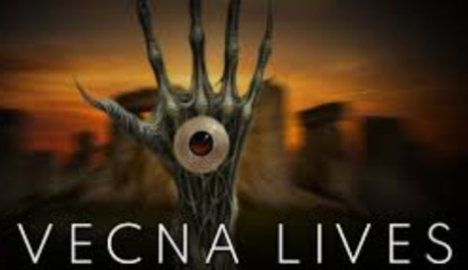 |  |  |  |  | Description
Name |  |  |  |  | Effort | ●  |  | Max Hit Pts |  | 1+Con Mod
Alignment |  |  |  |  | Fray Die | None |  | Level |  | 1
Attribute |  | Score | Modifier | Check / Save  (23 - stat) | Skills (Highlight those you possess. Gain 5 at 1st level; One is at Advantage)
Strength |  |  |  |  | Athletics (Jump, Swim, Climb, balance, flips, falls)
Dexterity |  |  |  |  | Sleight of Hand (Pick Pockets, Open Locks, Disarm Traps), Stealth
Constitution |  |  |  |  | No skills. Used to resist poison, hold breath, resist damage, etc.
Intelligence |  |  |  |  | Arcana, History, Investigation, Nature (Knowledge), Religion
Wisdom |  |  |  |  | Handle Animal (ride), Insight, Medicine, Perception, Seamanship, Survival (Tracking, Hunting, finding shelter)
Charisma |  |  |  |  | Deception, Intimidation, Performance, Persuasion
Consuming Temptation | What do you care about or dislike with passion?
Race
Anima Banner
Fact: “Class”
Fact: History | Hero of Silverymoon. Gain +2 on Social checks in this region.
Talent

Talents / Words / Gifts / Powers
Weapon Proficiencies | (Two):

Armor & Weapons (BAB +1 each level)
Armor: | Shield: | DEX Mod: +X |  | Total AC (Armor+Dex mod + Shield):
Weapon: | To Hit Attribute Mod: +X |  | Total to Hit (level + Mods): + |  | Damage:
Weapon: | To Hit Attribute Mod: +X |  | Total to Hit (level + Mods): + |  | Damage:
Weapon: | To Hit Attribute Mod: +X |  | Total to Hit (level + Mods): + |  | Damage:

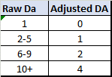
Damage Conversion Table:

Notes

Equipment (10+ Str Mod) | Treasure

Background / History / Misc

