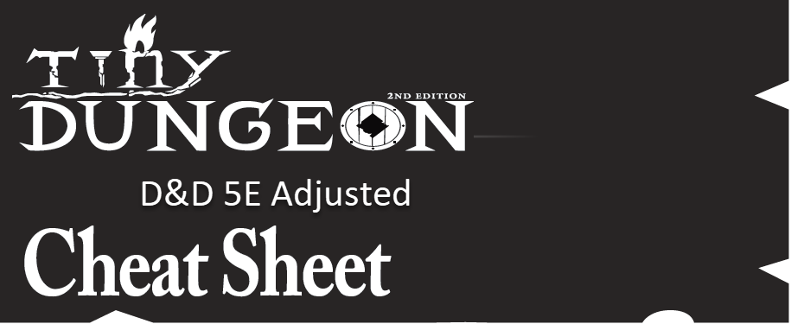

Tests
The core mechanic is called a Test, or a check, which is a roll of 2d6. Tests are successful if you roll a 5 or 6 on any of the dice rolled in your dice pool:
- Advantage: roll 3d6
- Standard: roll 2d6
- Disadvantage: roll 1d6
- Saving Throws: roll 2d6
- Disadvantage trumps Advantage

Healing
Six (6) hours of sleep and rest heals your character fully and restores all your spells. You can regain one (1) Hit Point per hour of rest otherwise.

Death
- Unconscious at zero (0) Hit Points. You cannot go lower than zero Hit points
- One the PC’s next turn, make a Save Test to stabilize; if you fail,
- Roll another Save Test one round later. Failure is character death
- If the Save Test is successful, the PC is at zero HP’s and unconscious until rested or Healed

Items & Equipment
You have 6 inventory spaces, each with 3 slots. A slot can hold any of the following items:
- A weapon, potion, torch, 1 day’s rations, cloak, 50’ rope, 100 coins, a magical scroll or a wand
- Your character starts with your armor, weapon, backpack, whatever your Heritage and Traits dictate and $25 gp
You cannot carry more than your allowed slots.
- A Light melee weapon only needs one hand to wield. This allows you to do other things with your off-hand. Examples include dagger, short sword, mace, club, staff
- A Heavy Melee weapon requires 2-hands and may provide a 10’ reach if the Reach Trait is taken. Examples include long sword, spear, war hammer, great club.
- A Ranged weapon can be loaded and fired each combat round. It is assumed you always carry enough ammunition for your adventure
- Armor and Shields are affectations and have no mechanical impact without a character Trait
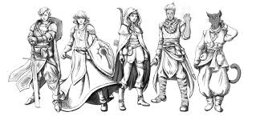

Combat
Combat will be managed simultaneously for all combatants with the following phases:
- Move – you may move up to your full movement
  - Including climbing, swimming, jumping, etc.
  - Half-move to stand from prone; does not provoke an opportunity attack
- Combat Action Options – One Action per round in order:
  - Ready - state the situation and then take your action after the situation occurs
  - Dodge or Evade – Roll 1d6 to avoid each hit
  - Help an ally with a non-Attack action. Gives Advantage if both parties have the skill
  - Take an Action - such as Hide, Open a door, cut a rope, and etc.
  - Missile attack – Test to hit
  - Magic – Test to cast a spell. Or use a scroll or magic item
  - Disengage – move away from enemies without provoking an opportunity attack
  - Melee attack – Test to hit
  - Grapple attack. Test as normal. If hit, the opponent Saves or is “held”; size impacts.
  - Dash – give up your Action to move your full movement a 2nd time in the round
- Remaining Movement – if you had any movement remaining from phase 1, you may use it at the end of the combat round. This could provoke an Opportunity Attack by leaving a threatened hex
- A successful attack does 1 damage unless otherwise noted by a Trait, magic item, or special ability
- Shooting into melee combat is at Disadvantage
- Free or Bonus Actions – these actions take no time and can occur during any phase:
  - Use a potion
  - Make a quick (unstudied) Perception check
  - Communicate a short sentence. (Not a full conversation)
  - Drop something including your backpack
  - Ready a weapon or put it away
  - Drop prone to the ground (free Evade Action vs missile attacks, Melee attacks against you are at Advantage)

