The First Crusade to liberate the holy lands ended in disaster. The invasion failed to keep the holy lands from the wicked heathens and the relics of God were lost. It’s a period after the Crusade and mankind is feeling the impact of the loss; creatures, man, and even the land is being corrupted by Satan and chaos is running rampant across the British Isles. Will the dream of a united Albion envisioned by King Arthur ever be realized?

Welcome to the Dark Ages
You will be playing a heroic character that has been blessed by God. You are a person with innate powers that have recently started to manifest in men, creatures and even the landscape. Nobody is sure what caused God to take revenge on some and bless others, but the impact on everyday life and society is just starting to be realized.

The rules and notes that follow are for the Players of the Templar Campaign. These notes include things known by most people in the area where the characters live. This includes information about the general society, the world, history, culture, and the general attitudes of the populace. Please use the information for RPG ideas and character generation. Additions or changes can be made if it adds to the role playing experience of the Players.

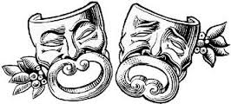

History
In this alternate world, it can be assumed that history progressed as on our Earth until the First Crusade; around the year 1095 A.D. After that time, manifestations of seemingly magical powers started to appear around the world. Here is a brief summary and what your characters know:

- 6th Century BC – Prehistoric Britain. No recorded history but strange monuments and stone megaliths are scattered about the land.
- 5th Century to 1st Century BC – British Iron Age. Tribes of Picts, Gauls, and Gaels invade and settled the British Isles.
- 55 BC – Julius Caesar leads the first Roman invasion of Britain.
- 43 AD – The first Roman province of Britannia is founded.
- 122 AD – Emperor Hadrian begins building a wall on the Scottish border.
- 128 AD – Hadrian’s Wall is completed.
- 140 AD – The Romans conquer Scotland.
- 209 AD – Saint Alban becomes the first British Christian martyr.
- 306 AD – Constantine the Great Declared Emperor at York.
- 401 AD - The Romans withdrawing from Britain. Anglo Saxon migrants begin to settle in England.
- 410 AD – Vikings start raiding Britain.
- 450 to 750 AD - Invasion of Britain by the Jutes from Jutland, Angles from South Denmark and Saxons from Germany.
- 460 AD - St. Patrick converts Ireland to Christianity.
- 597 AD - St Augustine brings Christianity to Britain from Rome and becomes Archbishop of Canterbury.
- 750 AD - Britain is divided up into seven Kingdoms; Northumbria, Mercia, Wessex, Essex, Sussex, England, and Kent.
- 793 AD – First mass invasion by the Vikings.
- 871 AD - King Alfred defeats the Vikings but allows them to settle in Eastern England
- 926 AD – Eastern England is conquered by the Saxons.
- 1042 AD - Edward the Confessor becomes King of England.
- 1055 AD – Westminster Abbey is completed.
- 1066 AD - The Battle of Stamford Bridge: Saxon victory over invading Vikings.
- 1078 AD – Work starts on the Tower of London.
- 1095 AD - Pope Urban II declares a Crusade against the infidels to retake the holy lands and bring back holy relics.
- 1099 AD - The Crusade ends in disaster. The armies of God are defeated and the holy relics are lost.
- 1100 AD - Manifestations of God’s blessings and Satan's curses are reported. "Monsters" are seen in Britain.
- 1113 AD – Rumors of children being taken by various factions for the Church.
- 1117 AD – Characters are at the Durham Monastery. Start of the campaign.

Local History
For the last several years, you have been living in the outskirts of Durham. A northern city that is also the capital of the County. There has been an occasional Viking raid that the senior Knights have thwarted. Other than that, your time has been spent on your studies and chores.

The area where you live is a small monastery a short walk (about 2 miles) to the North Sea on the eastern side of the British Isles. Your area is a typical city of equivalent technology, laws, and customs to that of other medieval towns in Great Britain. The highest form of technology is the water wheel for milling grains and a new wondrous device, a water-clock.

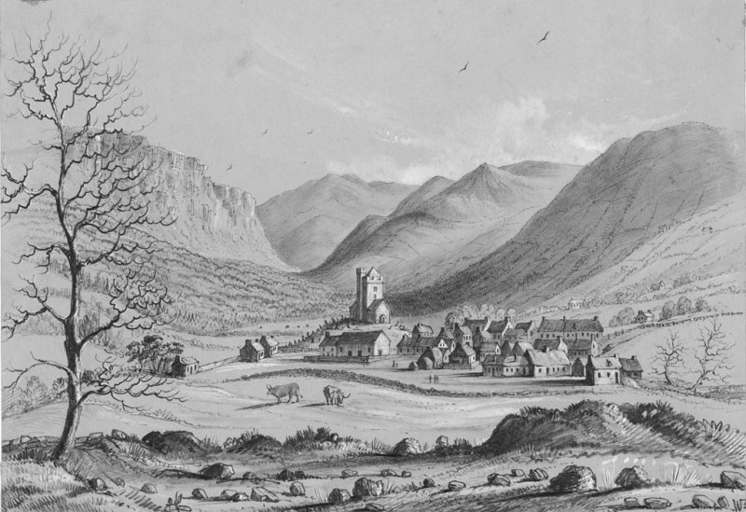

Local Government
Durham, being a city of about 15,000 people, has a religious leader, the Bishop of the area, and a secular leader known as Duke Lancaster.

Local Military Strength
The city has about 300 guards to protect the people that also act as the local police force that also patrol the country-side. In your estimation, this is not enough men.

Languages
The English language is the common tongue of the area. Some educated and wealthy people also know Latin. The literacy rate for the general population is only about 6% and those that can read/write (like the characters) are considered educated.

Laws
In most areas justice is based on the English Common Law philosophy; common sense and making restitution to those injured. In the British Isles, thieves are given the chance at restitution for first time offenders. Repeat offenders are usually banished, branded or imprisoned until they can repay their debt. In most cases thieves die in jail.

Murderers are executed. If there are questionable circumstances, the murderer is exiled with only their clothing. In judicial cases, the facts are presented to a judge or senior church official, they make a decision, and the sentence is carried out.

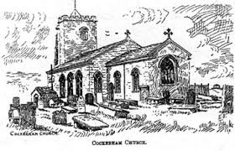

Religion & Spirituality
Most people in the British Isles are Christian. They worship God, Jesus, and the Holy Ghost trinity. They venerate Mother Mary as a Saint along with all other Saints anointed by the Church and Pope. In many cases, the Pope and his Priests have more authority over the people than the secular ruling kings, queens, and Dukes of the land.

People are quick to rat-out their neighbor if they think the neighbor is “evil” or is cursed by Satan. (Displaying “evil” magical powers.) (Yes, this is vague because there are no set rules about those Blessed and Cursed.)

Everybody goes to church on Sunday and it is a day or rest and worship. To violate the Sabbath invites the wrath of the church.

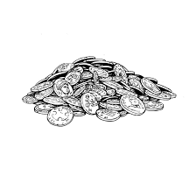
Economy
We will use the silver penny ($SP) as the standard unit of measure in the British Isles. To make conversion easy, substitute a $SP for a D&D gold piece. One British Gold Piece = 10 $SP = 100 copper pieces. Most people have never seen a gold piece and usually only deal in a copper or a small number of silver pennies.

Unlike our world, this medieval England is much more free. People are not indentured servants or surfs but they own their own land and work it to make a living. As such, a standard peasant farmer, fisherman, or laborer earns about $250 silver pieces $SP a year. Use all other economics and prices per the D&D rules substituting a $SP for a gold piece.

Because of the agrarian nature of the local community, there are only a few wealthy people in and around Durham. (Excluding the Nobles and Church officials.)

The economy of Durham is based on a few primary industries. Most of the people rely on farming, local hunting, fishing and crafting/construction jobs in and around the Capital. There are a few other jobs including blacksmith, cobbler, and other such necessary vocations in a city.

Taxes are collected by the local militia Captain at the end of each year. The tax equates to about $60 per year per adult person in a household. Those living in a religious institution are tax exempt. (This is a non-progressive flat tax.) You have heard rumors that taxes are much higher in other areas; as much as double or triple of what is paid in Durham.

Local farmer’s markets occur every Saturday morning. This has been a great opportunity to socialize with the locals and purchase hard-to-get items from traveling salesmen.

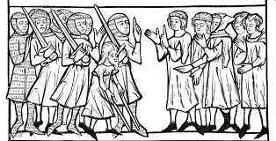

Ransom
The idea of paying ransom for somebody captured by an enemy is a cultural norm during this time. In most cases, people without financial means will not be ransomed, but those of noble blood and importance can be traded for a monetary exchange. In most cases, once a bargain is struck, both sides of the exchange honor their commitment. Failure to do so invites retaliation not only from those wronged by the broken deal, but others as well because of the broken honor that must be avenged. The typical values for ransom are as follows:

- Peasant / Commoner would be worth one year of their wages at a little under $1 SP a day or about $250 SP
- A Merchant or Well-off Commoner is worth about two year’s wages or $500 SP.
- A Knight or Lesser Noble is worth three times their annual income or around $2,000 SP
- And a Greater Noble or King is worth five times or more their income which is about $3,500 - $5,000 SP depending on their value

Until the ransom is paid, the prisoner is expected to be comfortably housed and cared for as their station/class warrants. This could be a burden to some captors. So, in many cases, the enemy will not pursue ransom but will opt for a treaty or some other agreement so their kidnapped victim can be released as soon as possible.

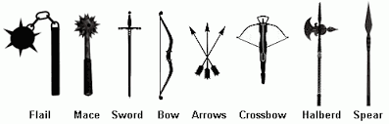

Weapons & Armor
Because Durham is a capital city, local residents do not normally possess weapons and armor of war. On occasion, mercenaries will be seen with such equipment. It’s not technically illegal for residents to carry such implements of war but if it’s done by someone not normally perceived as needing such items, the local militia may question the individual as to the need. Some natural exceptions are hunters who possess heavy leather armor and long bows, the local militia, and recently the Blessed.

Blessings of God & Curses of Satan
Until a few years ago, people with supernatural power did not exist. Now, to see such people display their “gifts” is only an uncommon occurrence.

There is a belief that because the Crusade failed, God rewards the faithful with powers in order to fight evil, the heathens, and Satan. It is also believed that if you have powers and fight for the Church, you are “Blessed by God” and are a holy person.

The contrary also holds true. If a person displays powers and is not fighting for the church or displays “evil” acts (wanton killing, taking advantage of others, and etc.), then you were cursed by Satan and are evil.

It is not clear how or why people, animals, and even portions of the land become blessed or cursed. Nor is it clear on the customs and laws that pertain to the Blessed and Cursed. All that is known is that since the Crusade failed, these people exist.

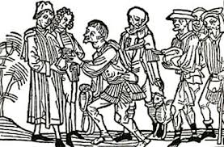

Your Daily Life
You were taken from your families when you were young and are now at the Durham Monastery training to become a Knight Templar. Right now, you are credited with the title of Acolyte. You are being trained to defend the Church and your fellow man from those that are Cursed and those that would do harm to or blaspheme the Church.

Your daily life consists of waking before sunrise
and performing some or all of the following duties:
- Prayer
- Chores - cleaning, feeding animals, milking cows, moving provisions, sweeping, drawing water, and etc.
- Latin & History lessons
- Martial training – learning to use weapons and armor. Learning what you favor most and how to use implements of war
- Learning to use your Blessed gifts
- Math and Military strategy
- Anything assigned by a Priest or the Monsignor of the Abbey

You retire at the end of each day to a large room/dormitory and sleep on an uncomfortable and often-times cold cot for a few hours before the cycle starts again the next day. Your only respite is ½ day on Saturday (where you usually go to the Farmer’s market) and all day Sunday where you spend most of your time in Church.

You have been told you are training to defend the Church and you must hurry to learn all you can. It is never known when and where Satan and his minions will attack.

As a Blessed member of the church, you have a comparatively comfortable life. You are housed in a dormitory, get 3 solid meals a day and can rely on secure shelter to keep out the elements and bandits.

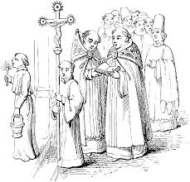

NPC’s
You have contact with many individuals in and around the Durham Monastery. Listed below are some of the NPC’s in the area:
- Monsignor Cavanaugh – religious leader of the Monastery. Gives the Priests directions and rules town issues when needed. A very serious man that takes holy scripture literally
- Father O’Donnell – Everybody’s favorite Priest. He is plump and nice to the Blessed. He likes good wine and can be bribed with a bottle or two
- Brother Patrick – the second priest of the Abbey. Middle-aged and very hard working. Always writing something in his journal in Latin. Believes that hard work is the road to salvation.
- Acolyte Ashton – only a little older (21) than the Blessed. He is learning the duties of a Priest and does what the other Priests tell him to do. At times he is serious and other times he misbehaves and is very relaxed.
- Captain Caldwell – leader of the local militia. A veteran of the Crusade. Not married and has lots of wounds that make him very ugly.
- Master Keaton – Martial / Weapons teacher at the Monastery. A task-master that yells a lot. “No Pain, No Gain!” is his moto.
- Professor Filmore – Latin & History teacher. More like a Sage. He belittles your intelligence at every opportunity.
- Cook Elda – Cook for the Abbey. She is middle-aged and plump with a husband and 3 kids that also work in the kitchen. She is a good listener and often gives pastry treats to the Blessed. She seems to know all the local stories.
- Master Gordon – Local tavern owner of the “Pious Pigeon”. (The name seems to be a private joke that nobody but Gordon understands.) He tells stories of when he was in the Crusade. He is missing his left hand. He charges the Blessed and Warriors minimally for their drinks.
- Master Jaxson – local Blacksmith. He can and has forged some of your weapons. He is a small man but seems very strong for his size.
- Master Jarrett – Local brewer. He supplies the Tavern with beer. Lately, you have not seen Jarrett but you have seen his 12-year-old son, Gerard, making the deliveries.
- Duke Lancaster – you have never met the man but you hear his name discussed between the Priests. He is somebody of political power and wealth.

Rumors
- Captain Caldwell can be bribed with gold. He is saving up money so he can have a large dowry to get a wife that will over-look his hideous injuries.
- Father O’Donnell use to be the head of the Abbey. He was forced to step down because he insulted the Duke.
- There is a pagan site where babies are sacrificed to appease Satan. Those that do the sacrificing gain evil powers!
- Master Jarrett is dead. Nobody has seen him in weeks and his son is providing for the family. They are not telling because they don’t want to lose their livelihood.
- See that guy over there?! He used to be a Blessed holy warrior. A true Paladin! But he somehow pissed off God and lost his powers. So all he does now is drown his sorrows at the local pub.
- I heard that Brother Patrick is a strange guy. He collects holy symbols. Every year he switches his allegiances to a new religion. He is a charlatan I tell you.
- There was a war in 1105 between 12 Blessed Knights and an army from Southampton. The Knights destroyed the opposing army of several thousand.

