Imperial Marines
The Imperial Marines or Imperial Star Marines are the armed fighting forces carried aboard Imperial starships. Marines deal with piracy and boarding actions in space, defend the starports and bases belonging to the navy, and supplement other ground forces such as the army.
- By reputation, the Imperial Marines are sent in when something or someone presents a serious threat to the well-being of the Imperium and its member worlds. They are never used lightly, and once committed, they never leave a job half-done.
- Some derogatorily call them the Lords of Space.
- Their primary motto is: “Obey”

Library Data Referral Tree
Please refer to the following AAB Library Data for more information:
- Imperial Navy (IN)
  - Colonial Navy
    - Subsector Navy
    - Planetary Navy
  - Imperial Star Marines (ISM)
  - Imperial Naval Intelligence (INI)
  - Naval Depot
- Imperial Army (IA)
  - Close Orbit and Airspace Control Command (COACC)
  - Ground Force Command (GFC)
  - Nautical Force Command, a Wet Navy (NFC)
  - Sylean Rangers
  - Colonial Forces (Planetary Defense Forces)
- Imperial Interstellar Scout Service (IISS)
  - Express Boat Network
  - Imperial Intelligence (ImpInt)
    - IISS Rangers
    - Rhylanor Taoiseach
  - Imperial Secret Service (ISS)
- Mercenaries
  - Imperial Rules of War
  - Mercenary Slang
  - Repatriation Bond

Description
The Imperial Marines are a tried and proven military force as well as the tip of the Emperor of the Third Imperium's might.

Image Repository
- Imperial Star Marines SEH.

Mission (Goals)
The marine's goal is simple: put down opposition to the Emperor anywhere, anytime, and for any reason. They stand as the elite end of interstellar force projection and are kept at the cutting edge if martial technology at a high expense. Marines typically employ top of the line TL-15 weaponry including battledress, FGMPs, and grav tanks.

Doctrine & Strategy (Operations)
No information yet available.

Rank & Grade (Hierarchy)
Imperial Marine Ranks
Commissioned Officers
O8 » Brigadier-General (Marshal)
O7 » Brigadier
O6 » Coronel
O5 » Lieutenant Coronel
O4 » Force Commander
O3 » Captain (Force Captain)
O2 » First Lieutenant (Force Lieutenant)
O1 » Second Lieutenant (Force Ensign)
O0 » Cadet / Midshipman
Enlisted
E9 » Sergeant Major
E8 » Master Sergeant (First Sergeant)
E7 » Leading Sergeant
E6 » Staff Sergeant (Gunnery Sergeant)
E5 » Sergeant
E4 » Lance Sergeant
E3 » Corporal
E2 » Lance Corporal
E1 » Marine/Private (Private 1st Class)
E0 » Marine Recruit / Apprentice
Some of the organizational ranks and grades used by this force are included in the table to the right.

Marines, Grades & Ranks
# | Grade | Remarks
E0 | Marine Apprentice | Marine recruits are Navy volunteers who go through an arduous selection process called "the Grinder"^{[1]}. They are then on probation for a period afterwards until they are promoted to the rank of Marine. Those that fail the "Grinder" or are deemed unsuitable for promotion during probation are "sent down" to the Navy as Ordinary Space Hands.
E1 | Marine/Private  (Private 1st Class) | None
E2 | Lance Corporal | Marine Asst. or Acting Fire-Team Leader or Specialist
E3 | Corporal | Marine Fire-Team Leader
E4 | Lance Sergeant | Marine Asst. or Acting Squad Leader
E5 | Sergeant | Marine Squad Leader or Acting Section Leader
E6 | Staff Sergeant | Marine Section Leader or Platoon Senior NCO.
(E6) | Section Sergeant | The honorary title granted to the senior NCO in a Marine Section, a sub-set of a ship's Marine detachment that can be as large as a platoon. A Section Sergeant is typically of grade E6 or E7. They assist the Marine commanding the Section, usually a subaltern officer or breveted NCO.
(E6) | Gunnery Sergeant | The lead Marine NCO of a Specialist sub-unit. Specialist Marines are considered technical or combat support rather than administrative support like Staff Marines. A Gunnery Sergeant is typically of grade E6 or E7. An E6 appointed as Gunnery Sergeant has generally been in-grade for some time and is more experienced, and is considered to outrank a Staff Sergeant.
E7 | Leading Sergeant | Marine Platoon Leader or Platoon Senior NCO, or sometimes the Senior NCO in a Marine Company.
(E7) | Leading Gunnery Sergeant | The lead Marine NCO of a Specialist sub-unit. Specialist Marines are considered technical or combat support rather than administrative support like Staff Marines.
(E7) | Colour Sergeant | The honorary title granted to the senior NCO in a Marine Company, who is responsible for carrying out special ceremonial and protocol duties.
(E7) | Ship's Sergeant | The honorary title granted to the senior NCO in a ship's Marine detachment. Large ships can carry a detachment as large as a company. A Ship's Sergeant is typically of grade E7 or E8.
E8 | Master Sergeant | Marine NCO supervising Specialist units or sub-units at the battalion or regimental level (e.g. Regimental Quartermaster Sergeant), and/or assisting a Sergeant Major.
(E8) | First Sergeant | The senior Marine NCO (grade E8) in a Marine Company. They are assigned to advise a Marine Company commander (usually a Captain).
(E8) | Chief Gunnery Sergeant | If there is more than one Gunnery Sergeant in a ship's crew or force, the senior Gunnery Sergeant is known as the "Chief Gunnery Sergeant". A Chief Gunnery Sergeant is typically of grade E8.
E9 | Sergeant Major | The senior Marine NCO (grade E9) in a Marine Battalion or Regiment (RSM). They are assigned to advise a Marine Battalion or Regiment commander. Mostly an honorary title because Marines usually serve in small units that are only notionally assigned to a higher command.
(E9) | Force Sergeant Major | The senior Marine NCO (grade E9) in a Force. They are assigned to advise a Marine Force commander.
(E9) | Fleet Sergeant Major | The senior Marine NCO (grade E9) in a Fleet. They are assigned to advise a Marine Fleet commander.
(E9) | Master Gunnery Sergeant | The senior-most Gunnery Sergeant in a Marine Battalion, Regiment, or Fleet is known by the title "Master Gunnery Sergeant", and is of grade E9.
O0 | Cadet / Midshipman | None
-- | Section Commander | A Marine officer (Grade O1) or breveted NCO (Grade E6-E7) in command of a sub-detachment of Marines equivalent to a squad or platoon in size. Occasionally a Marine Midshipman-in-training will temporarily hold this position, in which case he is often unofficially referred to as a "Third Lieutenant".
O1 | Second Lieutenant  (Force Ensign) | A Marine Officer leading a Platoon. Usually considered a commissioned officer-in-training.
O2 | First Lieutenant  (Force Lieutenant) | A Marine Officer leading a Platoon, or the Executive Officer of a Marine Company.
O3 | Captain  (Force Captain) | A Marine Officer in charge of a Company, or the Executive Officer of a Marine Force. The term Ship's Major is an honorary title bestowed upon a Marine Captain when on-board a ship so there will be no confusion between them and the ship's Captain, its commander.
O4 | Force Commander | A Marine officer who commands a Force of Marines. A Marine Force is made up of Ship's Detachments assigned under one Headquarters. A Force Commander may also be the Executive Officer of a Marine Battalion.
O5 | Lieutenant Coronel | A Marine officer who commands the Marines in a Navy Fleet/Task Group-level command or Battalion. A Lieutenant Coronel may also be the Executive Officer of a Marine Regiment.
O6 | Coronel | A Marine officer who commands the Marines in a Navy Fleet/Task Force-level command or Regiment.
O7 | Brigadier | Senior Marine officer rank, overseeing Fleet-level and/or Subsector-level (Numbered-Fleet) command responsibilities, and/or senior staffer on a Flag Officer’s Staff. It is a Navy appointment.
O8 | Brigadier-General | A Marine Brigadier who is promoted to the highest General-officer rank in the Imperial Marines. It is a Sector Fleet level (or occasionally multiple-Subsector Fleet level) administrative position, and is a Navy appointment.
(O8) | Marshal | A Marine Brigadier or Brigadier-General who is designated as overall commander of multiple Fleet-level commands in a theater of war. It is only used in wartime and is an Imperial appointment.
O9 | Brigadier-Commandant of the Corps | The highest ranking Marine Officer in the Imperial Marines. If one or more Marshals have been appointed, the rank is increased to Marshal-Commandant of the Corps. The Brigadier-Commandant's job is entirely political and involves representing the Corps at Court and getting support for its funding in the Moot. The Brigadier-Commandant normally holds a minimum noble title of Viscount.

History & Background (Dossier)
The Imperial Marines were founded by Cleon Zhunastu, who transformed the landing forces of the Sylean Navy into the Imperial Marines over 1,100 years ago. Weapons and tactics have changed, but the Marines’ basic function remains the same:
- Move fast..
- Strike hard and...
- Enforce the Emperor’s will.

Uncommon Mercenary Slang
Non-canon: Feel free to enter further information and/or personal experiences with this tradition.
- Alpha Oscar alert order, action order
- Bug Bomb biological weapon
- Delta Bravo dead body
- Delta Xray destroyed
- Dream Ticket a clear cut, straight forward battle, well paid, short term, ideal for a unit who wants to fight and leave.
- Rock(s) unguided ballistic ordnance
- Sierra Bravo standby
- Sierra Oscar Bravo (SOB) soul onboard
- Sploog Bomb chemical weapon
- Thunderball nuclear device

Force Composition
- Imperial Marine Regiment.
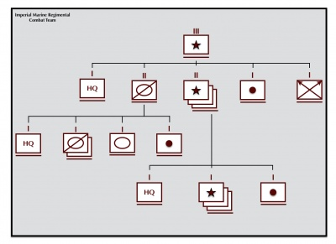
- Imperial Marine Task Force Headquarters.
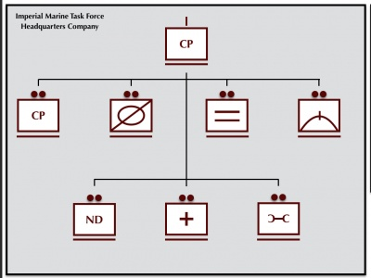
- Imperial Marine Task Force.
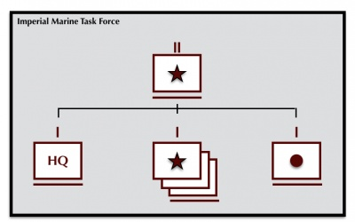
- Imperial Marine Lift Cavalry Troop.
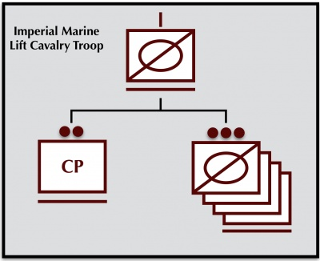
- Imperial Marine Lift Tank Company.
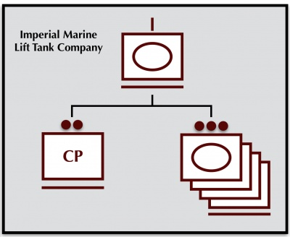
- Imperial Marine Lift Rifle Company.
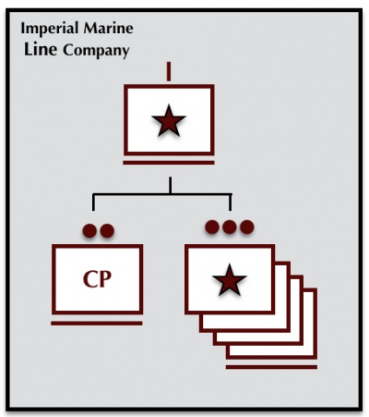
- Imperial Marine Meson Battery.
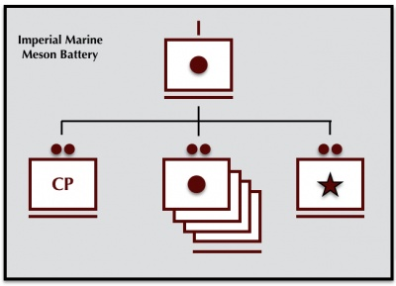

Selected Vehicle Classes
Some vehicle classes widely used within the systems and worlds of this force include:

Worlds & Sectors (Astrography)
This force primarily operates in the following areas:
Charted Space:
- Imperial Space

